Dear NDA member

As the NDA are working in Cooperation with this year’s World Demolition Summit, we would like to extend an invite for you to join us at on the 6th & 7th November at Münchenbryggeriet, Sweden Stockholm.

The event presents an excellent opportunity for everybody involved in the demolition sector to come together, network and discuss the latest technology, trends and developments in the industry.
For more information, please visit here.

Attendees will benefit from hearing a high-level technical conference that will feature presentations covering some of the most challenging demolition projects carried out around the world in recent months.

There is an outstanding line up of speakers attending:

- Mark Coleman – CEO Colemans – KEY NOTE SPEAKER
- Jan Rohde – Direct & Founder - GreenDozer
- Dr Yvonne Waterman – Founder – European Asbestos Forum

In addition, we have our Gala Awards Dinner taking place on the evening of the 7th, a truly fantastic evening celebrating the demolition industries annual achievements and successes.

As an NDA member, we are pleased to offer a 20% discount on delegate tickets.

To register your interest for the event, please contact Greg Roberts, or alternatively, use code NDA20 at checkout, to apply your association discount. Click here to register

We look forward to welcoming you in November.

Greg Roberts
International Sales Executive
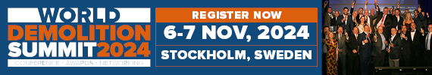
Tel: +44 (0) 1892 786238 |+44 (0) 7950 032224

